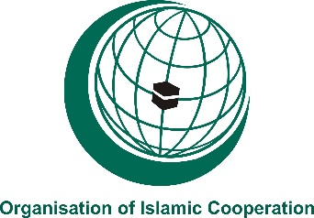
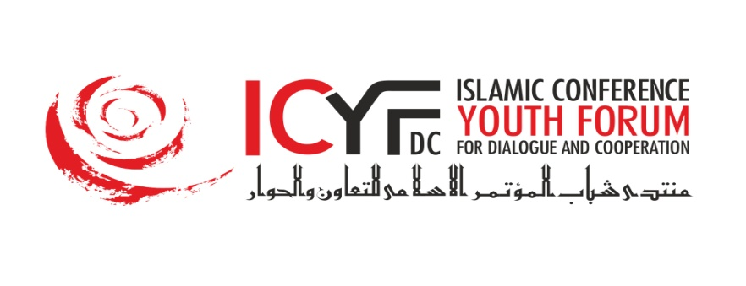

Annex 1
APPLICATION FORM
About the OIC Youth Capital Candidate City:
- Applicant city:

- Please provide general information about the city and its features.
(Use separate A4 sheets to respond to the questions below)
- Population of the city:
- Youth population of the city:
- Number of museums, art centers, Islamic and historical monuments:
- Describe regional and international accessibility to information about the City:
- Describe well known exhibitions, fairs, film festivals, youth activities and/or other events that held in the city annually or this year:
- Number of Training/conference centers/related facilities? (Please describe briefly their capacities):
- Availability of basic infrastructures (including hotels, 4 and 5 stars based on National Standards):
- Measures to be undertaken for facilitation visa/transport access to the international participants of OIC Youth Capital programme:

- Describe all social, cultural, academic events with international participation planned in case your city is selected as the OIC Youth Capital Programme. There should be min. 10 activities targeting min. 1000 young person, scheduled for the year and the division should be according to the charts below.

- Cultural Events (Min. 2 events)
Nr. | Title | Description (content, target, stakeholders, etc.)
1
2

- Academic Events (Min. 1 event)
Nr. | Title | Description (content, target, stakeholders, etc.)
1

- Entertainments (Min. 1 event)
Nr. | Title | Description (content, target, stakeholders, etc.)
1

- Social Event (Min. 1 event)
Nr. | Title | Description (content, target, stakeholders, etc.)
1
- Sportive Event (Min. 1 event)
Nr. | Title | Description (content, target, stakeholders, etc.)
1

- Intercultural Dialogue (Min. 1 event)
Nr. | Name | Description (content, target, stakeholders, etc.)
1

- Youth leadership and capacity building (Min. 3 events)
Nr. | Name | Description (content, target, stakeholders, etc.)
1
2
3

- Describe the expected local, national, international partnerships, networks that you can cooperate with during the activities within OIC Youth Capital. (Please mention some examples from your past experiences with the mentioned partners, networks if there is any)

- Describe the National Committee and the plan of their involvement.

- Describe your strategy and concrete plans to ensure the visibility of OIC Youth Capital Programme on local, national and international level?

- Budget: Amount of budgetary allocations to be reserved for the implementation of the programme.

Total Value – Direct Allocation:
Total Value - In-Kind Contributions:

Note: At least 10 % of the overall budget should be allocated for the programme related overhead expenses of the Implementing Agency.
Name Surname:
Position:
Name of the Host Agency:
Signature and Stamp:

***Each page of the application form should be signed by the legal representative of the applicant.
***Instrument of assessment of the selection process will be clearly distributed to all member states to ensure the objectivity of the evaluation exercise;

Signed and Scanned Applications should be received by the ICYF-DC Secretariat (through below mentioned contacts) no later than 18 June 2018.
Fax: +90 212 465 3670
E-mail: oicyouthcapital@icyf-dc.org

